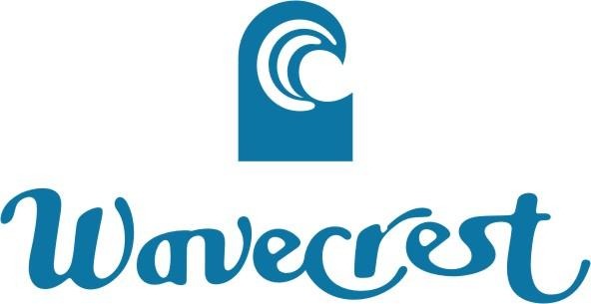
CHECK-IN FORM

Arrival Date | Departure Date | Unit # | Number of Persons in Party
Homeowner Guest/Renter
PRINT NAME _____________________________________________
HOME ADDRESS__________________________ CITY ___________________
STATE ____ ZIP _______ TELEPHONE _________________
EMAIL ADDRESS _______________________________
TYPE OF VEHICLE __________________ LICENSE PLATE # __________________
IN CASE OF EMERGENCY WHO SHOULD WE CONTACT?
NAME _________________________ PHONE #: __________________

*By signing below, I acknowledge that I have read and understand the house rules. I am aware that by violating these rides, a fine may be given to the unit that I reside in.

SIGNATURE: _________________________

**WAVECREST IS NOT RESPONSIBLE FOR PROPERTY LEFT IN VEHICLES, UNITS, LAUNDRY ROOMS, OR AROUND THE GROUNDS.
***PLEASE NOTE: All children 3 years and younger MUST wear swim diapers in the pool. This is a health issue and noncompliance are subject to an immediate $100 fine.

Complimentary swim diapers are in the cabana.

Also, our laundry equipment has been updated. Please use HE Laundry Detergent only! HE detergent is available for purchase at Front Office for $l.

