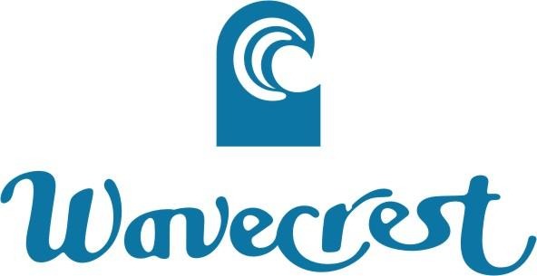

HOMEOWNER CONTACT INFORMATION UPDATE
UNIT NO.: ____- - ________
OWNER NAME(S): ___________________________________________
E-MAIL ADDRESS: ___________________________________________
HOME PHONE NO.: ______________________________
CELL ULAR PHONE NO.: ______________________________
WAVECREST PHONE NO.: ______________________________
MAILING ADDRESS: ___________________________________________
___________________________________________
___________________________________________
VEHICLE INFORMATION: ___________ ____________ ___________ __________ _______
(Color) (Make) (Model) (License Plate No.) (Parking Pass #)

PLEASE COMPLETE THE FOLLOWING:
Do you have an On-Island Representative: YES NO If yes, Name: _____________________ [HRS Ch. 521] Phone: ____________________
How often is your unit checked? __________________

Do you rent out your unit? [Act 326] YES NO If yes, Short Term Long Term

Maintenance/Access First Contact Preference: Owner On-Island Rep

Updated Information Declaration Page Sent? YES NO
Do you have Keys in the Office? YES NO
Do you have a Lockbox? YES NO Lockbox Code: ___________________
(Optional)
Do you have a Shut-Off Valve in your unit? YES NO

Do you have a Washer? YES NO

Do you have a Dryer? YES NO

Do you have Kayak(s) stored under the cabana? YES NO If yes, QTY?: ________
Description(s): ____________________
Additional Information:
Do you have an Icemaker installed? YES NO

Date Updated: ________

